GPS Demo1

# 1. Untitled Scene

## 1.1 Start

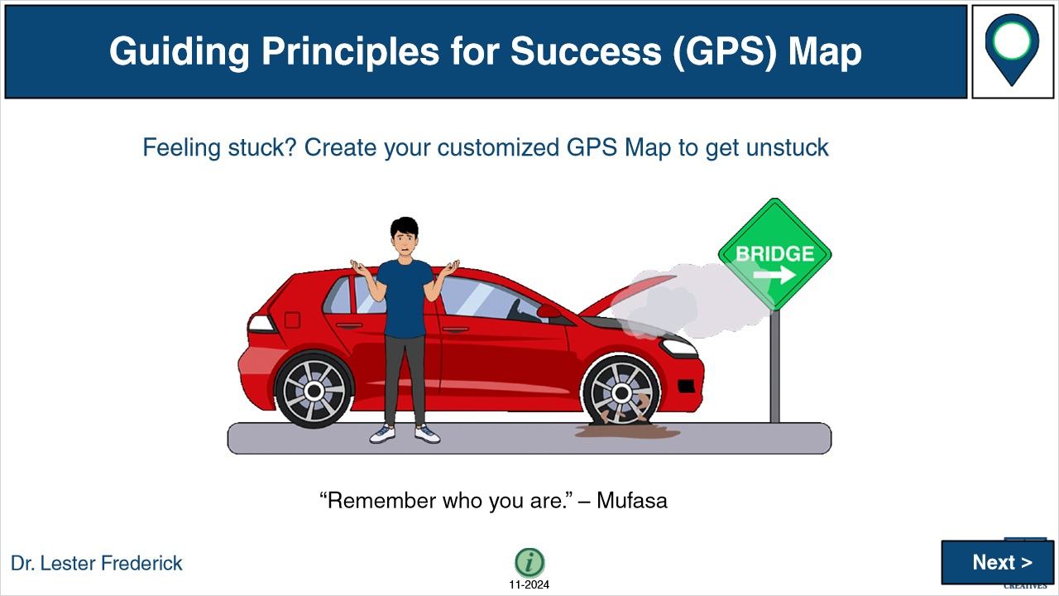

**Notes:**

### Untitled Layer 1 (Slide Layer)



## 1.2 GPS

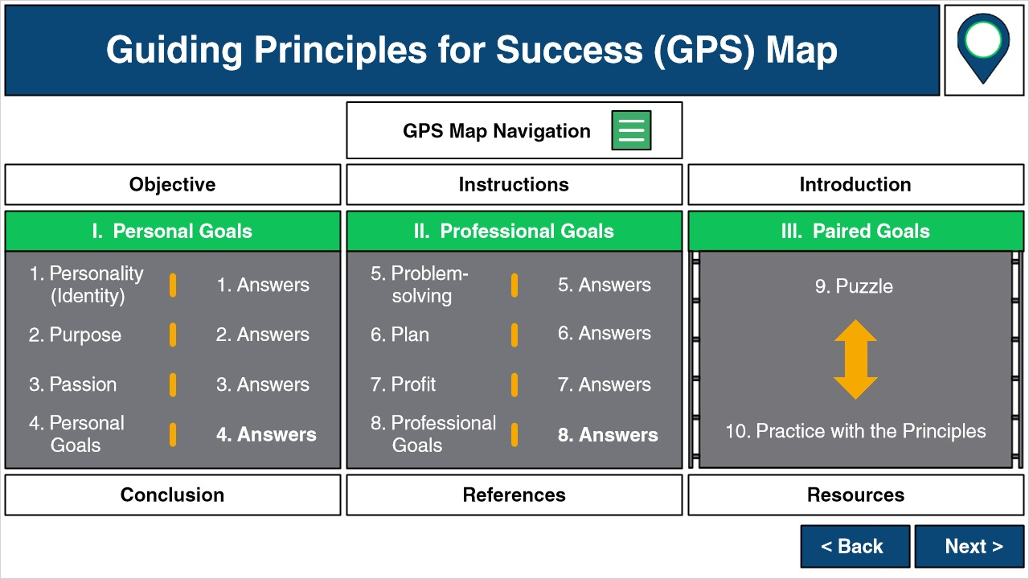

**Notes:**

### Objective (Slide Layer)

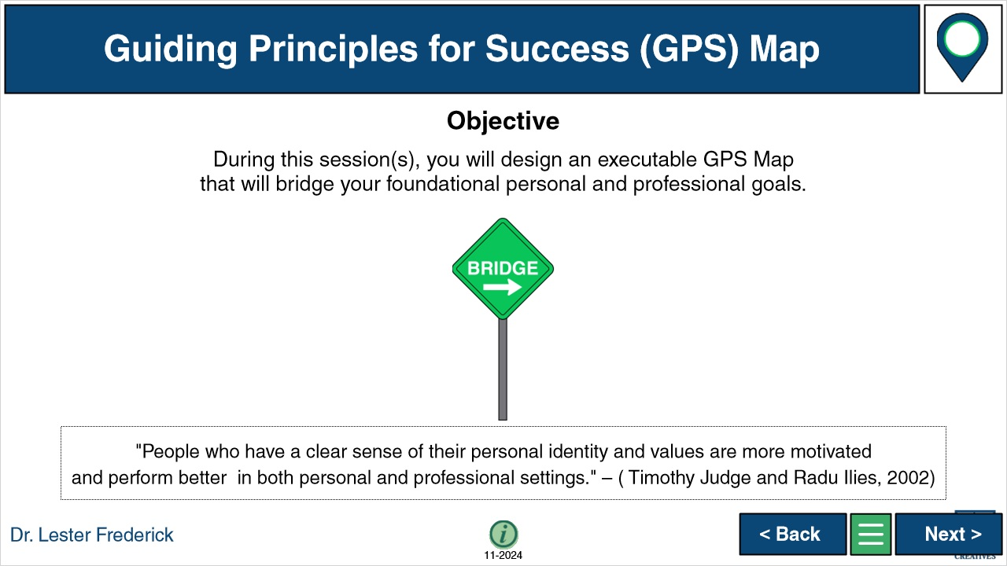

### Instructions (Slide Layer)



### Untitled Layer 1 (Slide Layer)



## 1.3 Objective

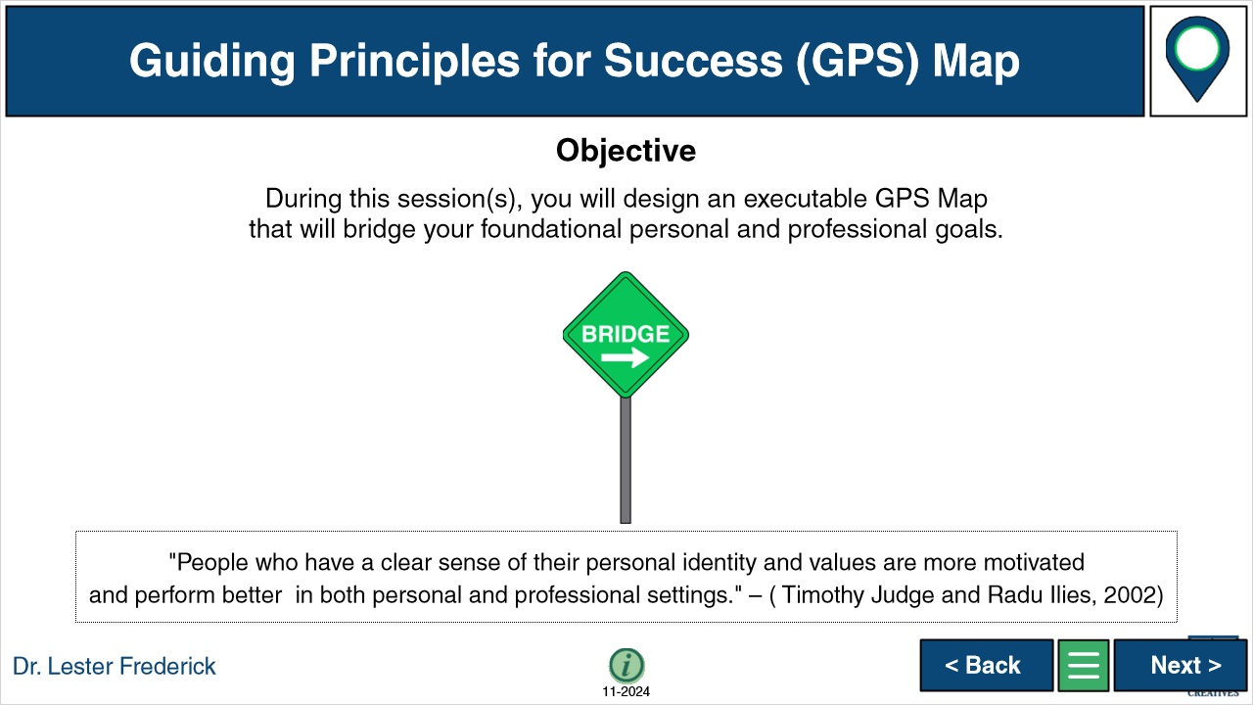

### Untitled Layer 1 (Slide Layer)



## 1.4 Instructions



**Notes:**

### Untitled Layer 1 (Slide Layer)



## 1.5 Introduction

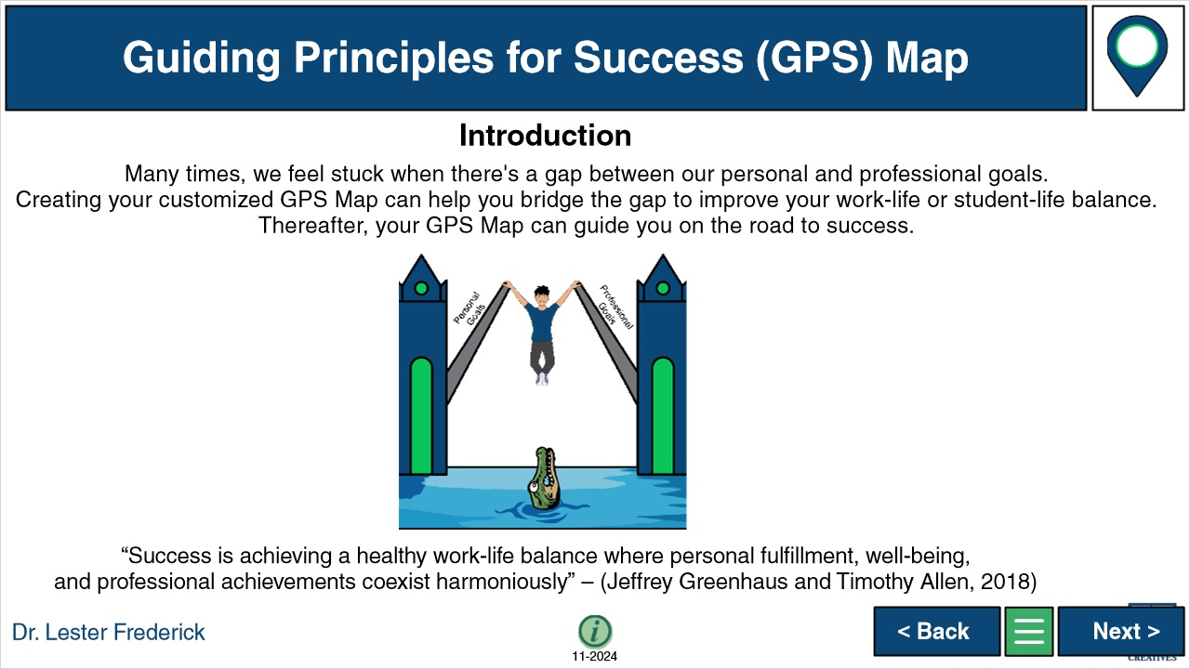

**Notes:**

### Untitled Layer 1 (Slide Layer)



## 1.6 Slide 6 Start

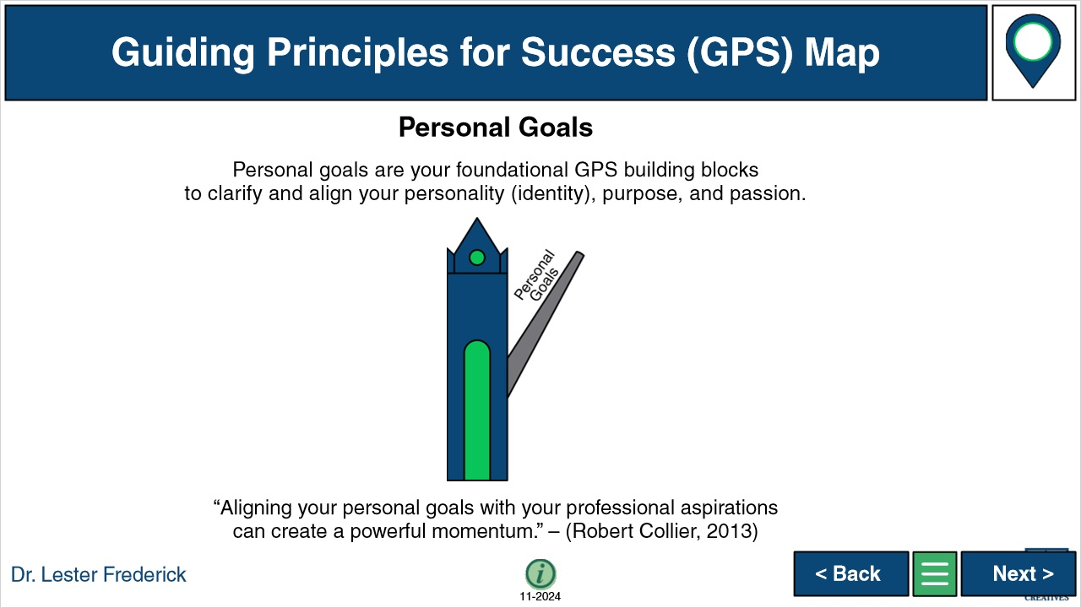

**Notes:**

### Untitled Layer 1 (Slide Layer)



## 1.7 Q Slide 1 - Explanation - Start

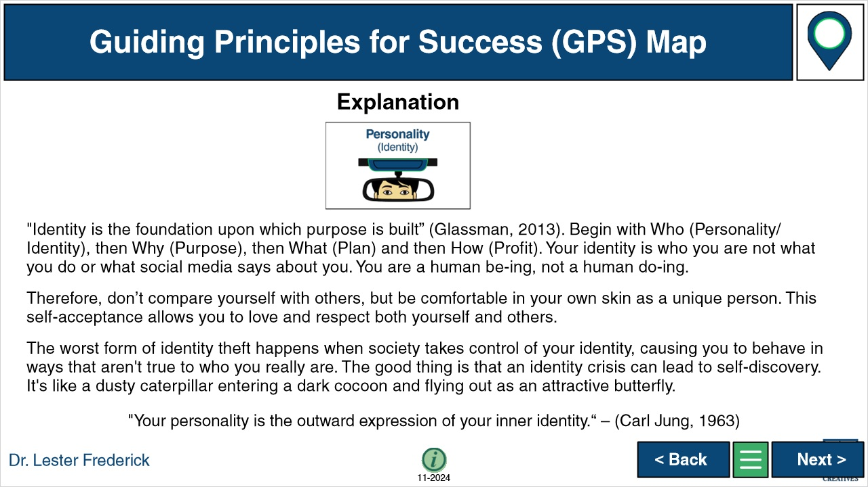

**Notes:**

### Untitled Layer 1 (Slide Layer)



## 1.8 Personality (Identity)

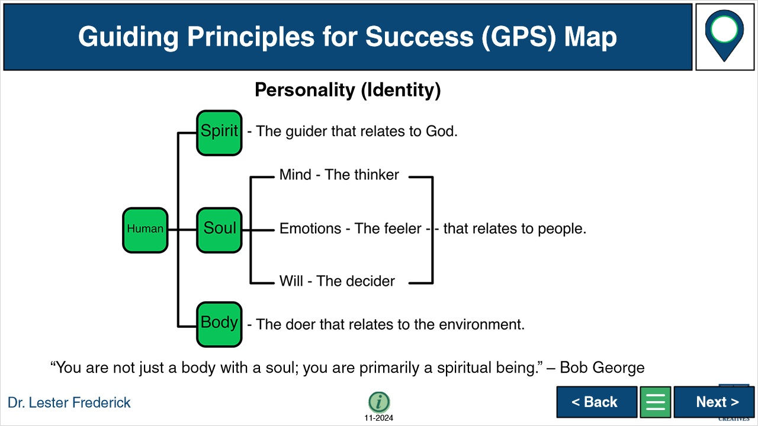

**Notes:**

### Untitled Layer 1 (Slide Layer)



## 1.9 Q Slide 1 - Instructions - Start

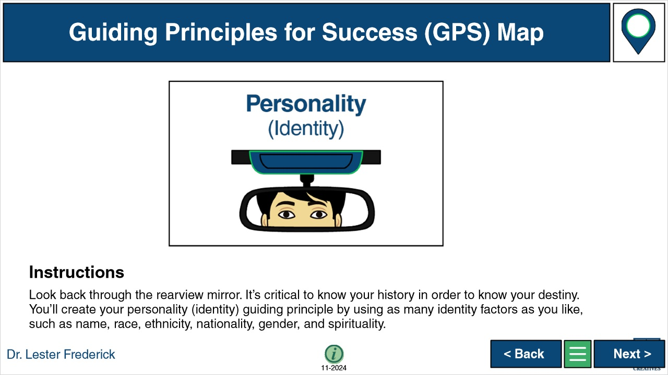

**Notes:**

### Untitled Layer 1 (Slide Layer)

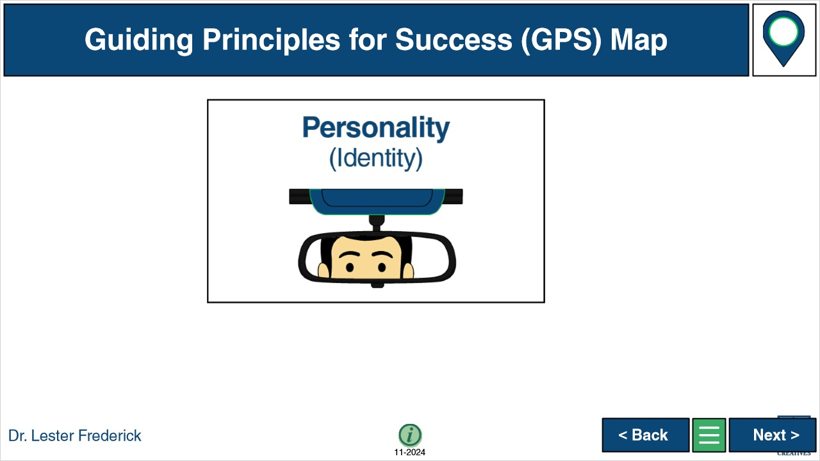

## 1.10 Q Slide 1 - Example - Start

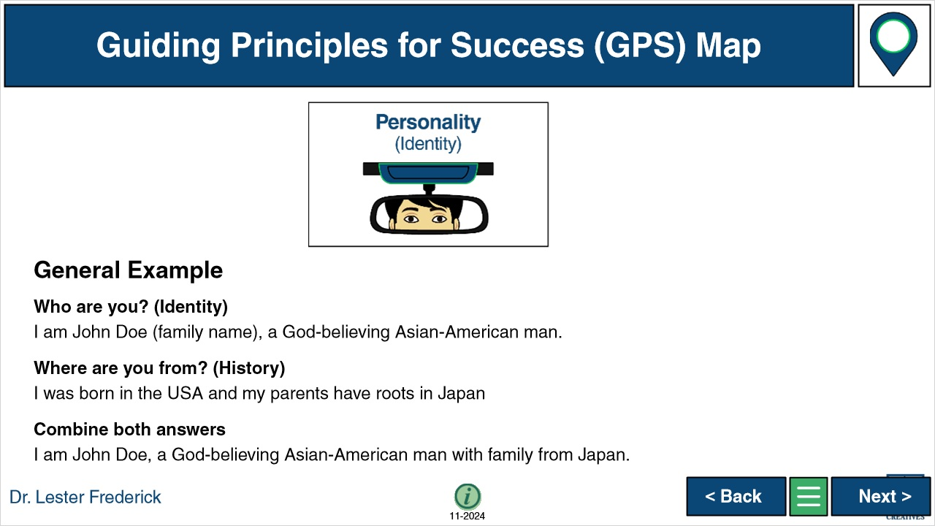

**Notes:**

### Untitled Layer 1 (Slide Layer)

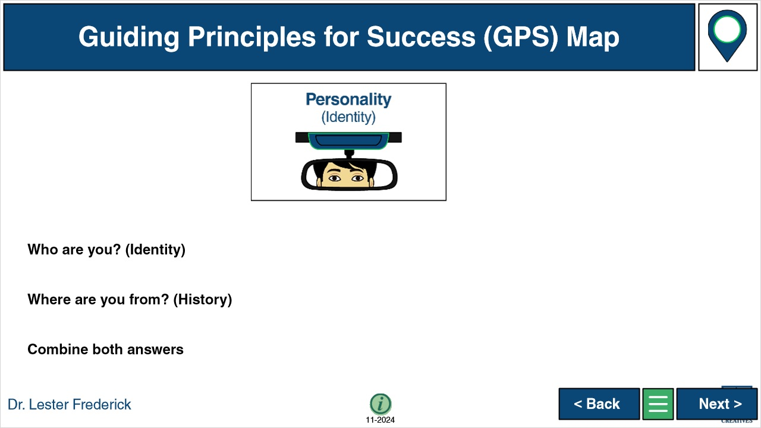

## 1.11 Q Slide 1 - Answer - Start

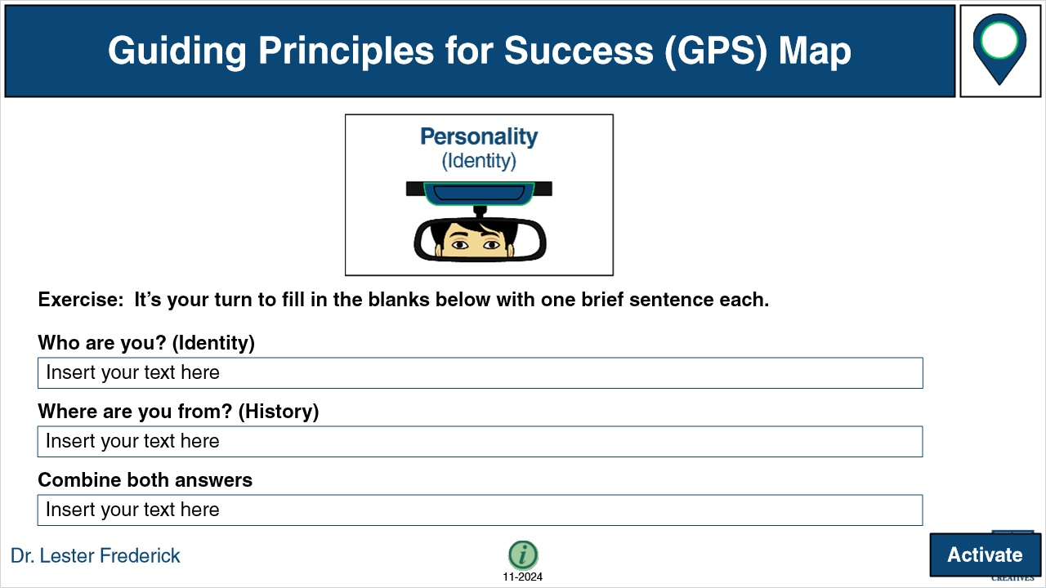

**Notes:**

### Untitled Layer 1 (Slide Layer)



## 1.12 Q Slide 1 - Optional Reflection Notes

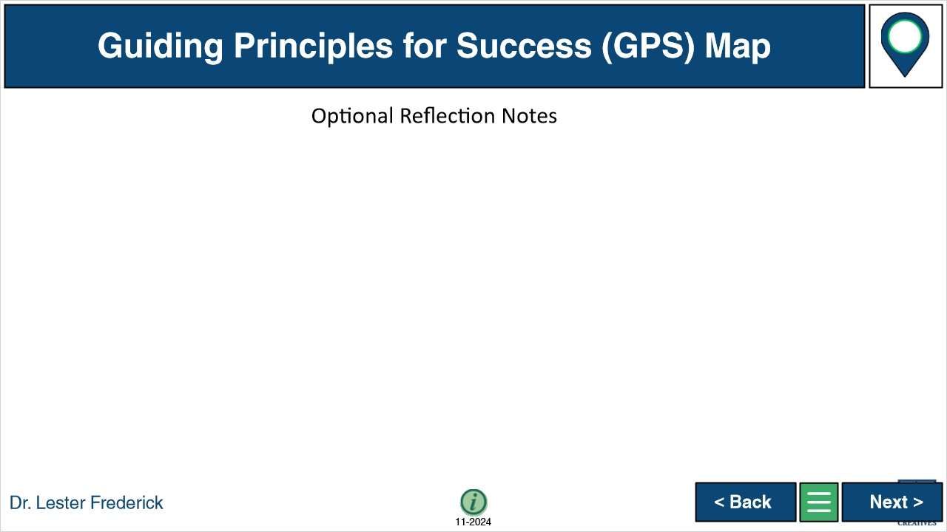

**Notes:**

### Untitled Layer 1 (Slide Layer)



## 1.13 Q Slide 2 - Explanation - Start

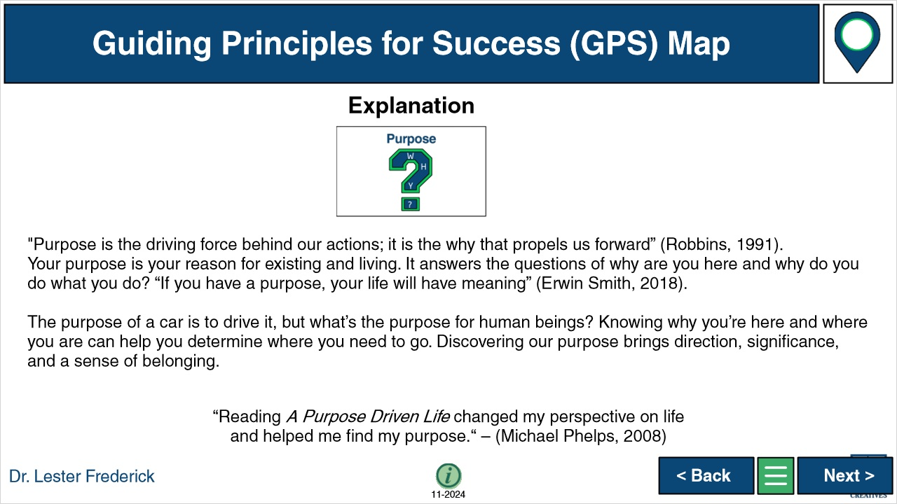

**Notes:**

### Untitled Layer 1 (Slide Layer)



## 1.14 Q Slide 2 - Instructions - Start

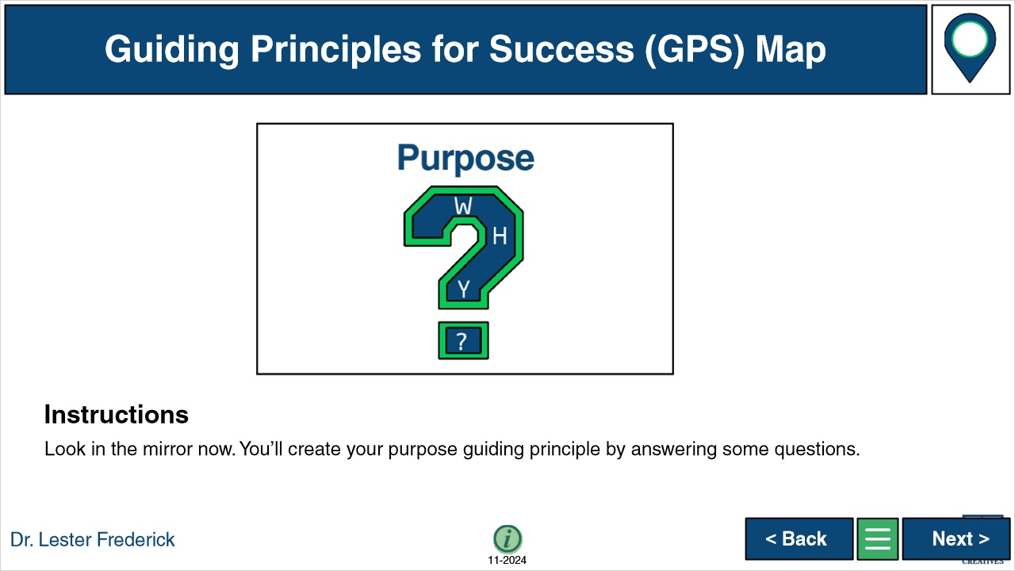

**Notes:**

### Untitled Layer 1 (Slide Layer)

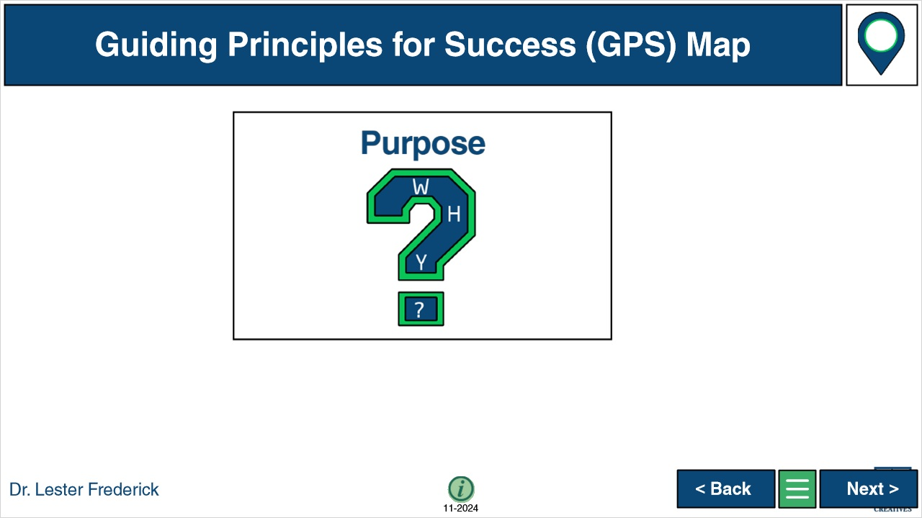

## 1.15 Q Slide 2 - Example - Start

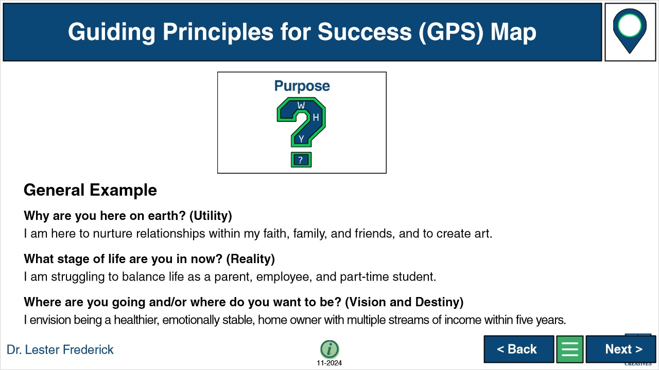

**Notes:**

### Untitled Layer 1 (Slide Layer)

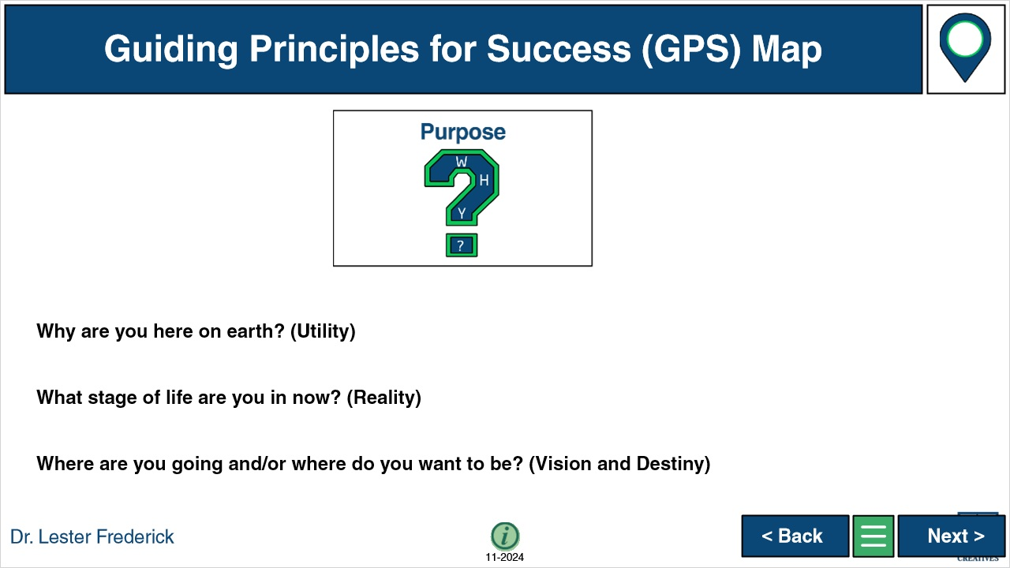

## 1.16 Q Slide 2 - Answer - Start

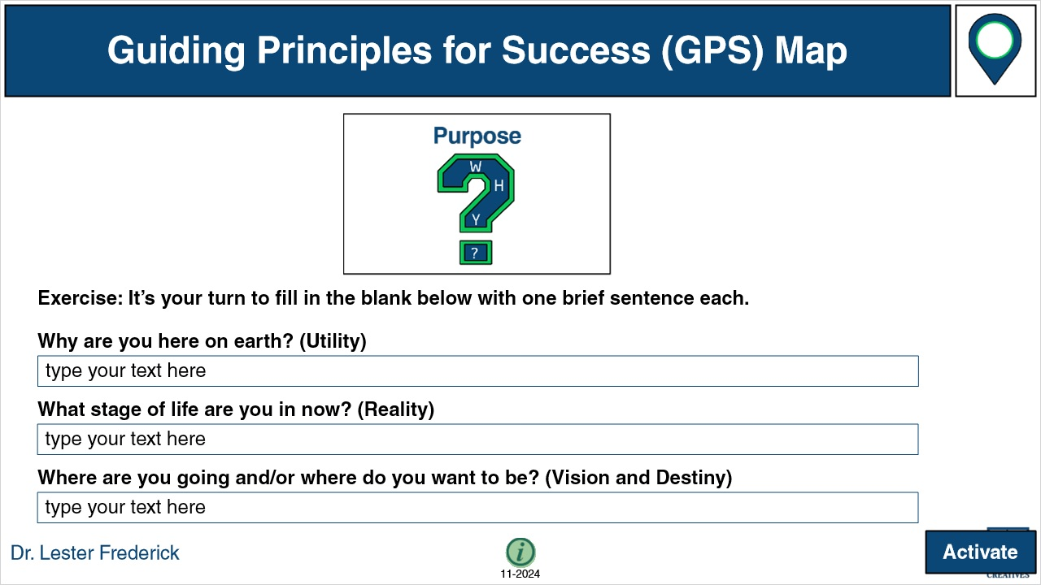

**Notes:**

### Untitled Layer 1 (Slide Layer)



## 1.17 Q Slide 2 - Optional Reflection Notes

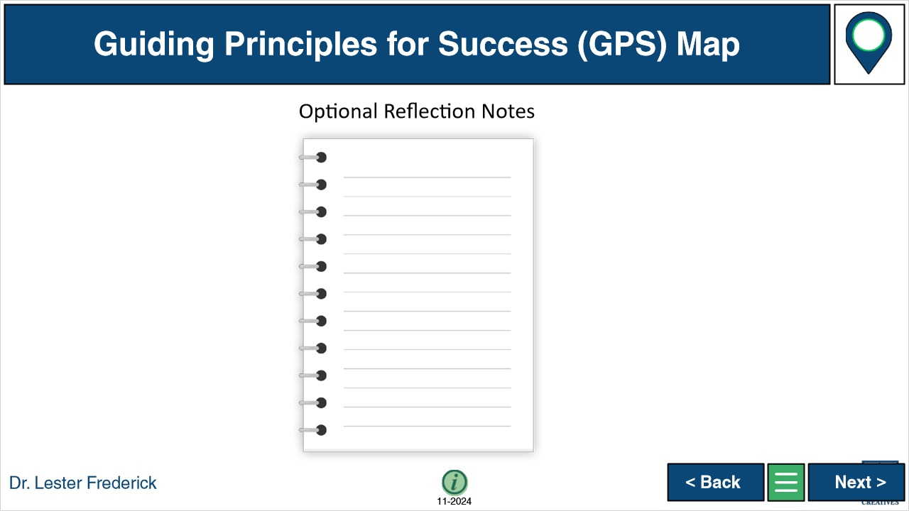

**Notes:**

### Untitled Layer 1 (Slide Layer)



## 1.18 Q Slide 3 - Explanation - Start

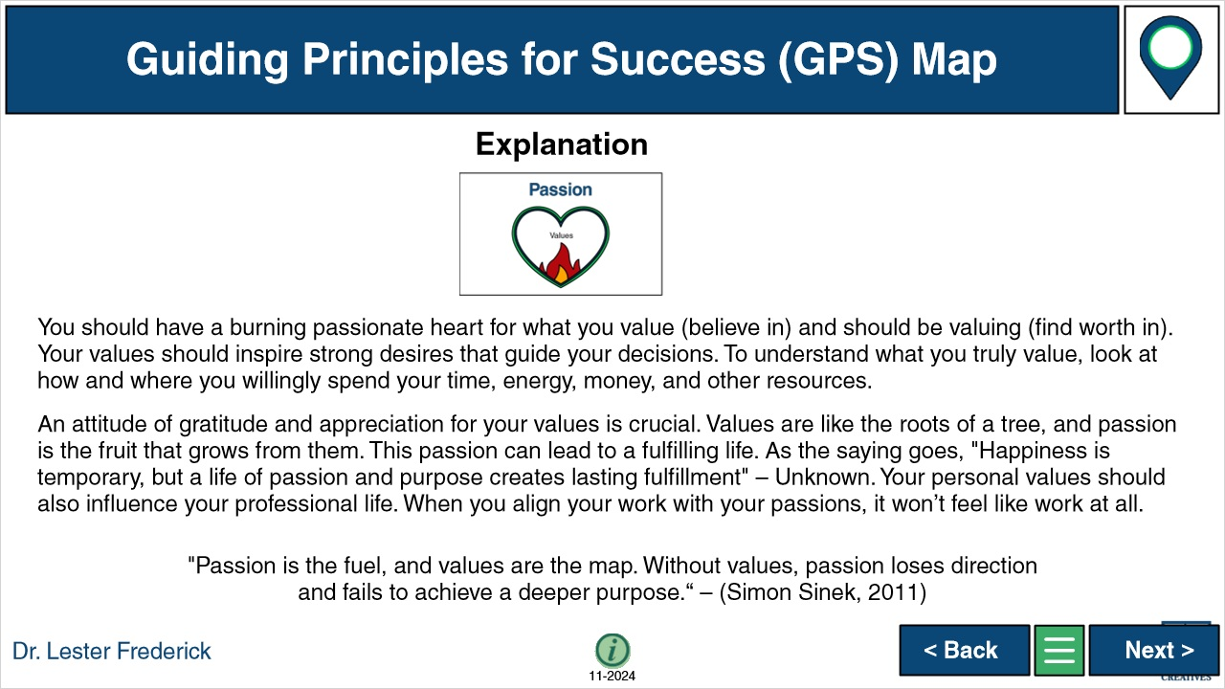

**Notes:**

### Untitled Layer 1 (Slide Layer)



## 1.19 Q Slide 3 - Instructions - Start

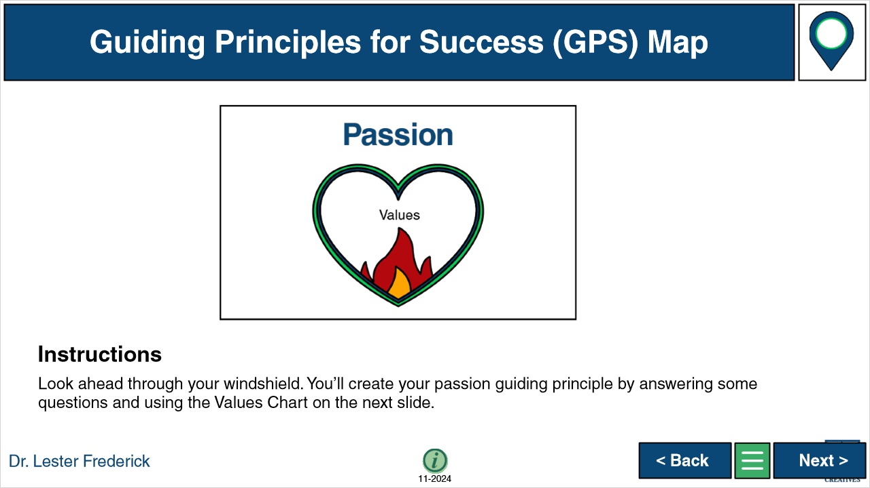

**Notes:**

### Untitled Layer 1 (Slide Layer)

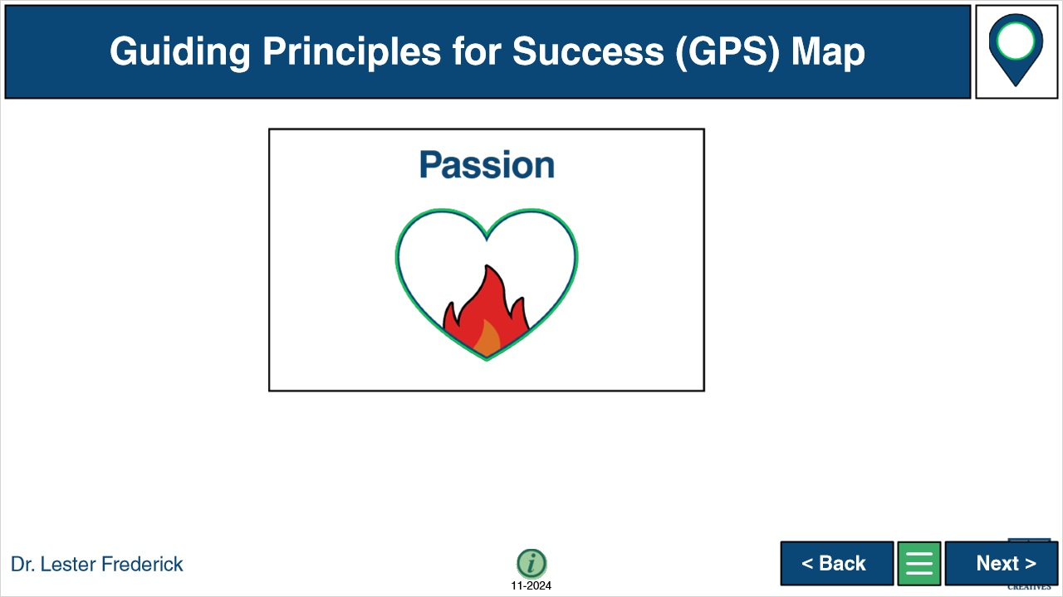

## 1.20 Q Slide 3 - Values Chart

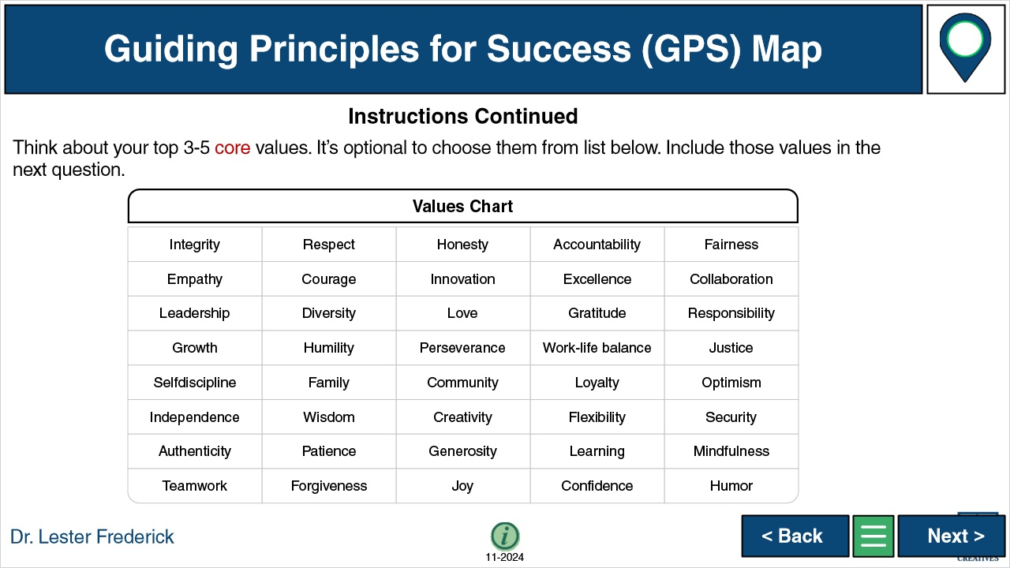

**Notes:**

### Untitled Layer 1 (Slide Layer)

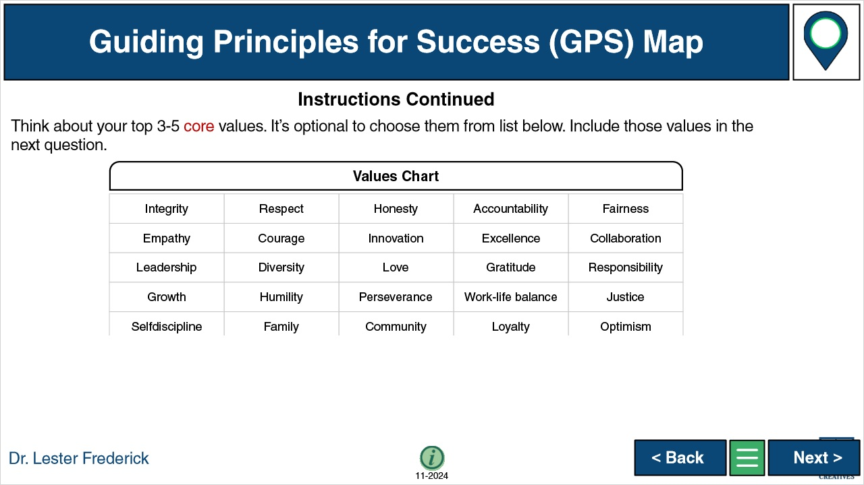

## 1.21 Q Slide 3 - Example - Start



**Notes:**

### Untitled Layer 1 (Slide Layer)



## 1.22 Q Slide 3 - Answer - Start

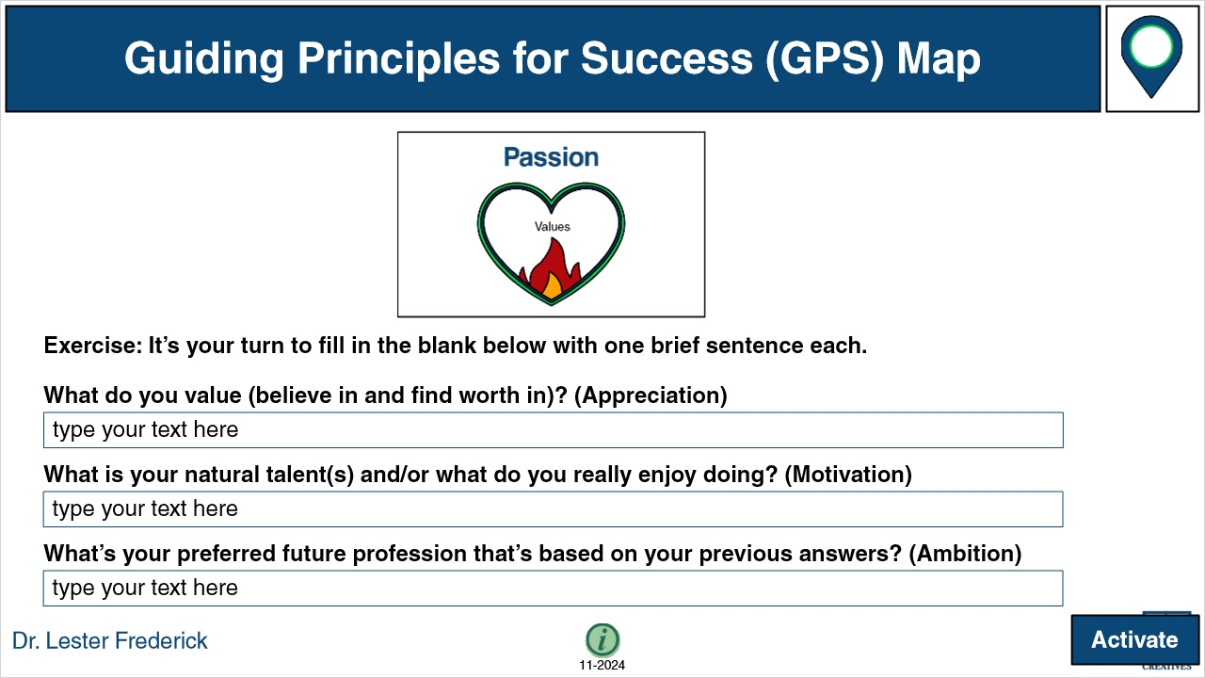

**Notes:**

### Untitled Layer 1 (Slide Layer)



## 1.23 Q Slide 3 - Optional Reflection Notes



**Notes:**

### Untitled Layer 1 (Slide Layer)



## 1.24 3 Answers

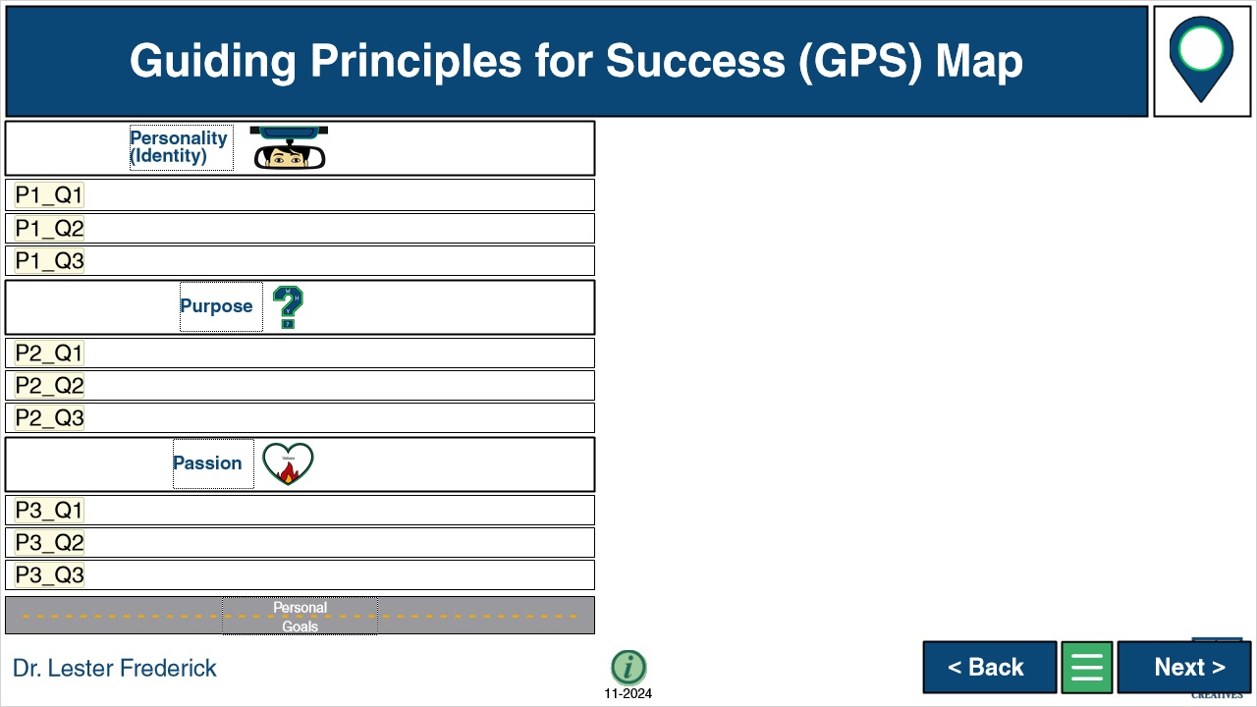

**Notes:**

### Untitled Layer 1 (Slide Layer)



## 1.25 Slide 5 Start

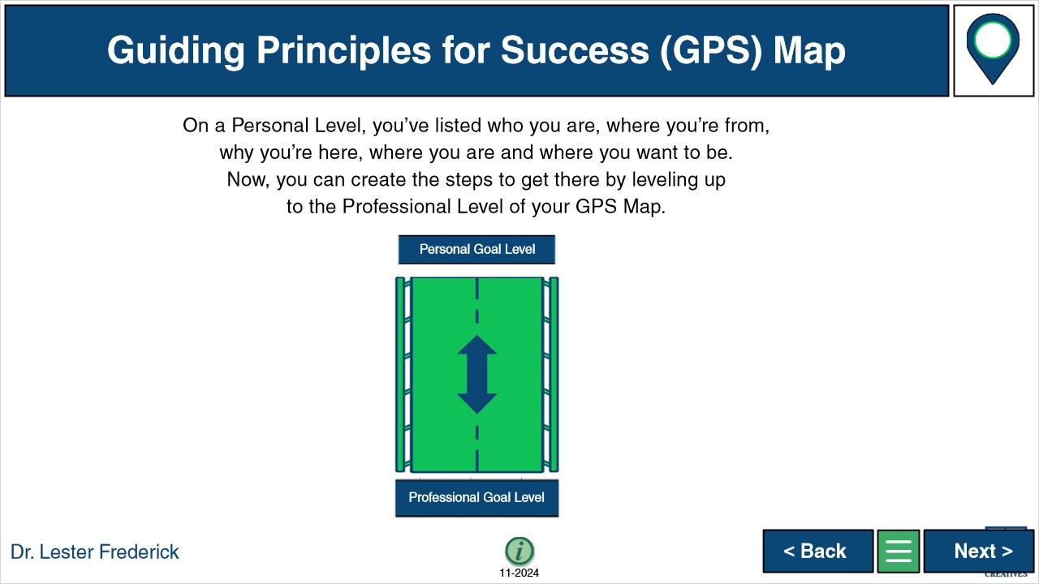

**Notes:**

### Untitled Layer 1 (Slide Layer)



## 1.26 Slide 6 Start

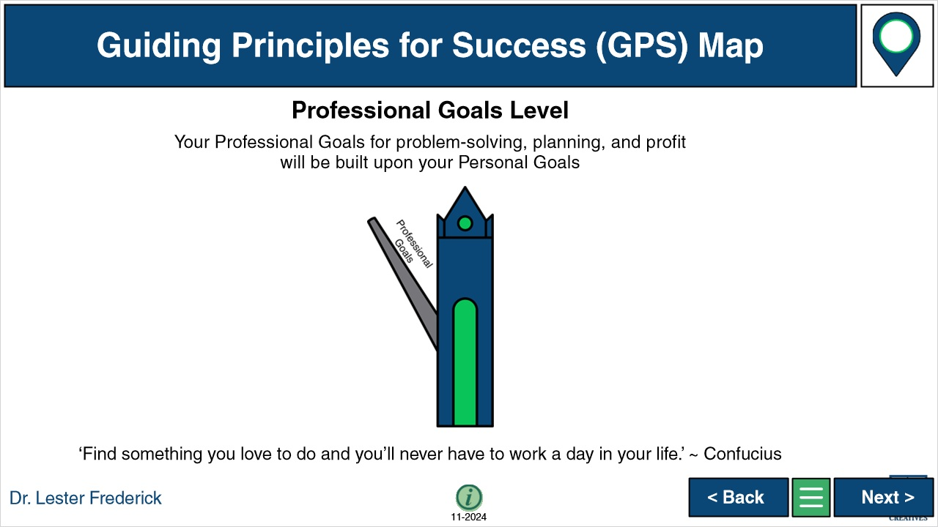

**Notes:**

### Untitled Layer 1 (Slide Layer)



## 1.27 Q Slide 4 - Explanation - Start

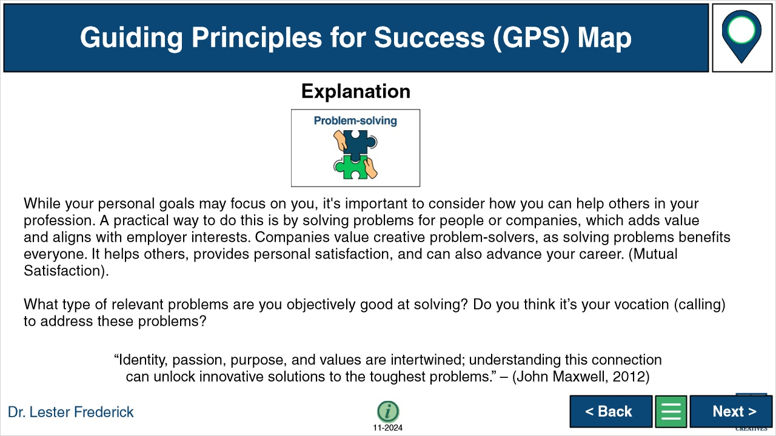

**Notes:**

### Untitled Layer 1 (Slide Layer)



## 1.28 Q Slide 4 - Instructions - Start

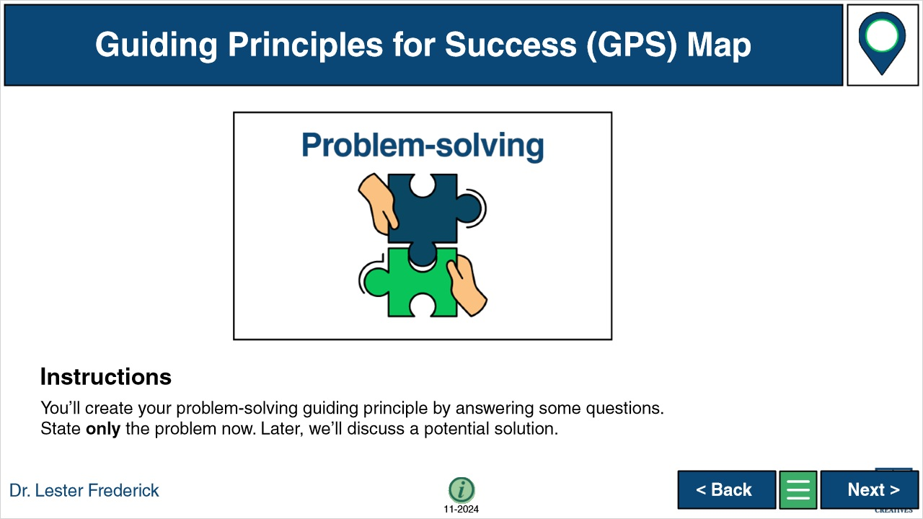

**Notes:**

### Untitled Layer 1 (Slide Layer)

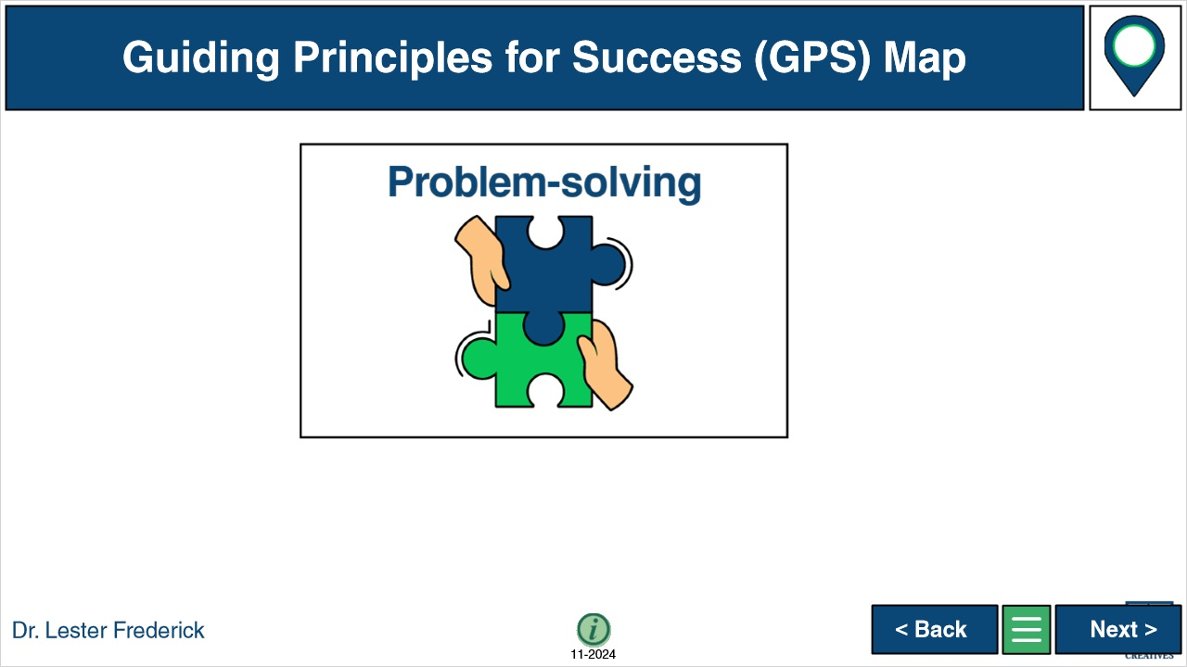

## 1.29 Q Slide 4 - Example - Start

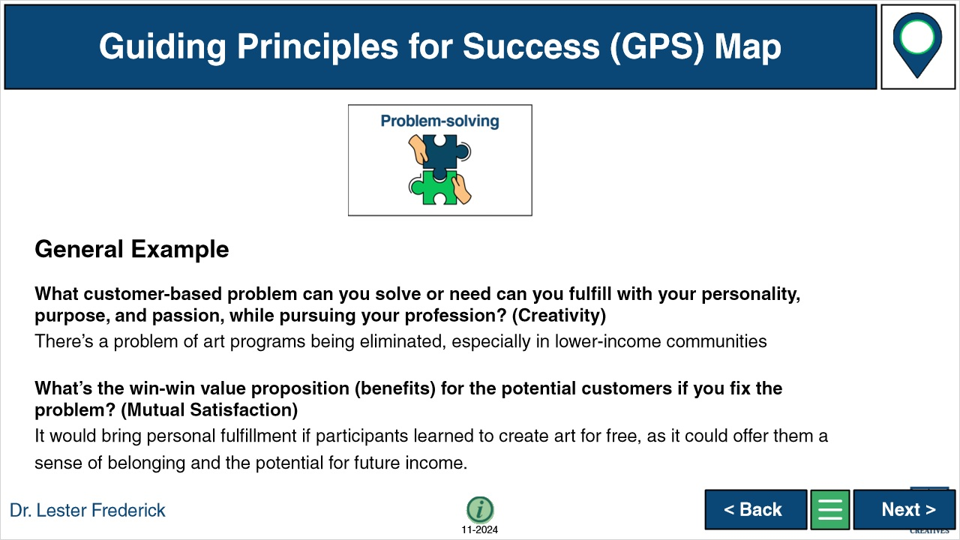

**Notes:**

### Untitled Layer 1 (Slide Layer)

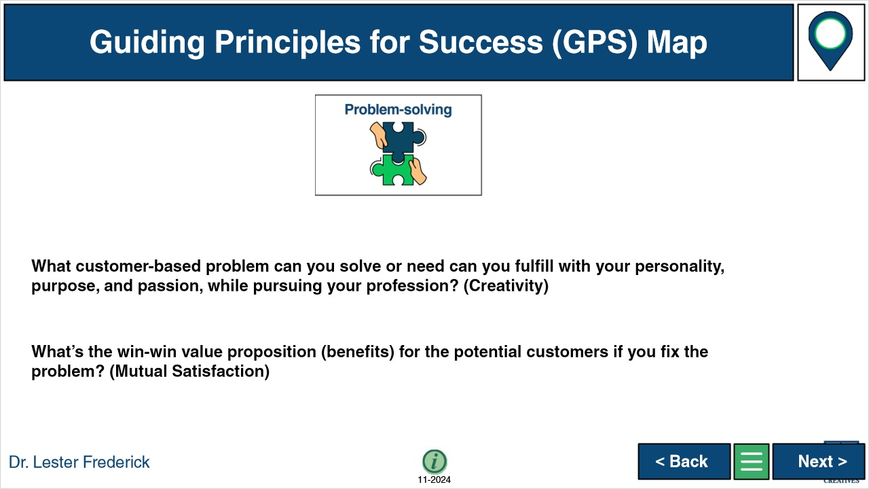

## 1.30 Q Slide 4 - Answer - Start

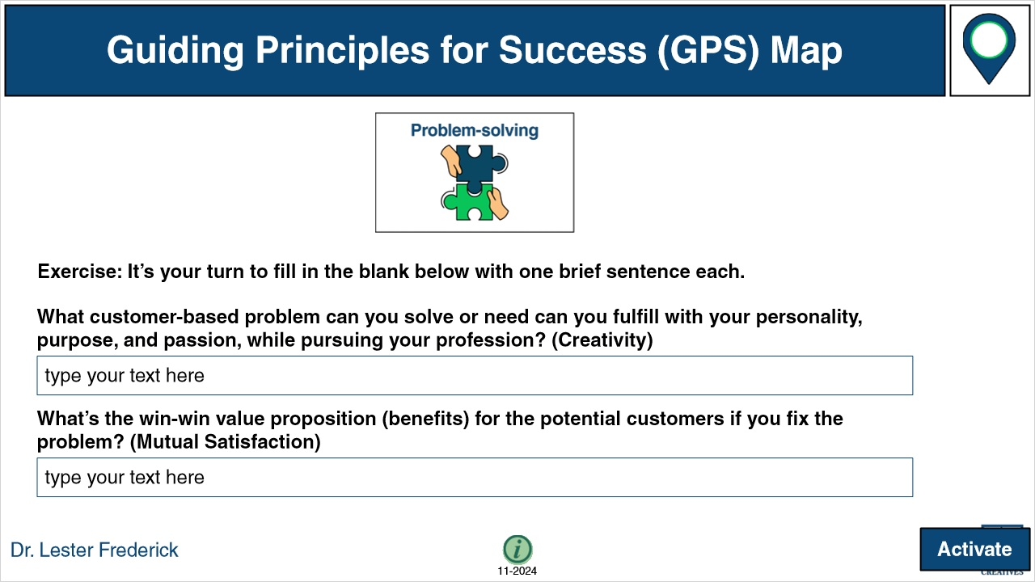

**Notes:**

### Untitled Layer 1 (Slide Layer)



## 1.31 Q Slide 4 - Optional Reflection Notes



**Notes:**

### Untitled Layer 1 (Slide Layer)



## 1.32 Q Slide 5 - Explanation - Start

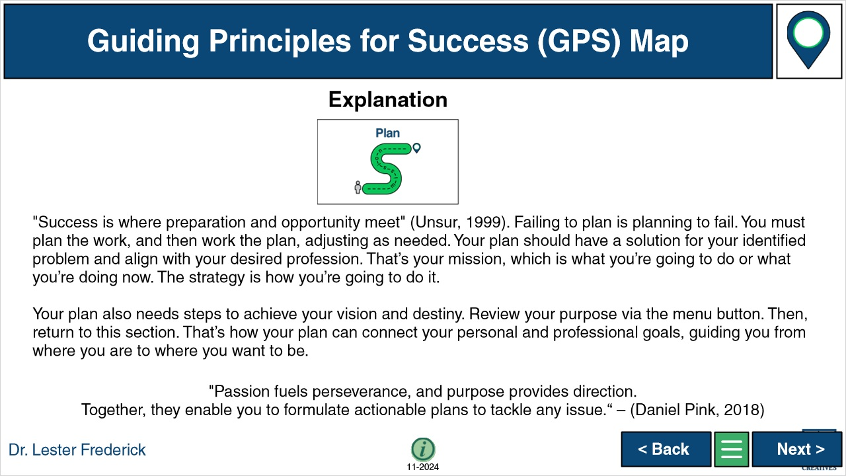

**Notes:**

### Untitled Layer 1 (Slide Layer)



## 1.33 Q Slide 5 - Instructions - Start

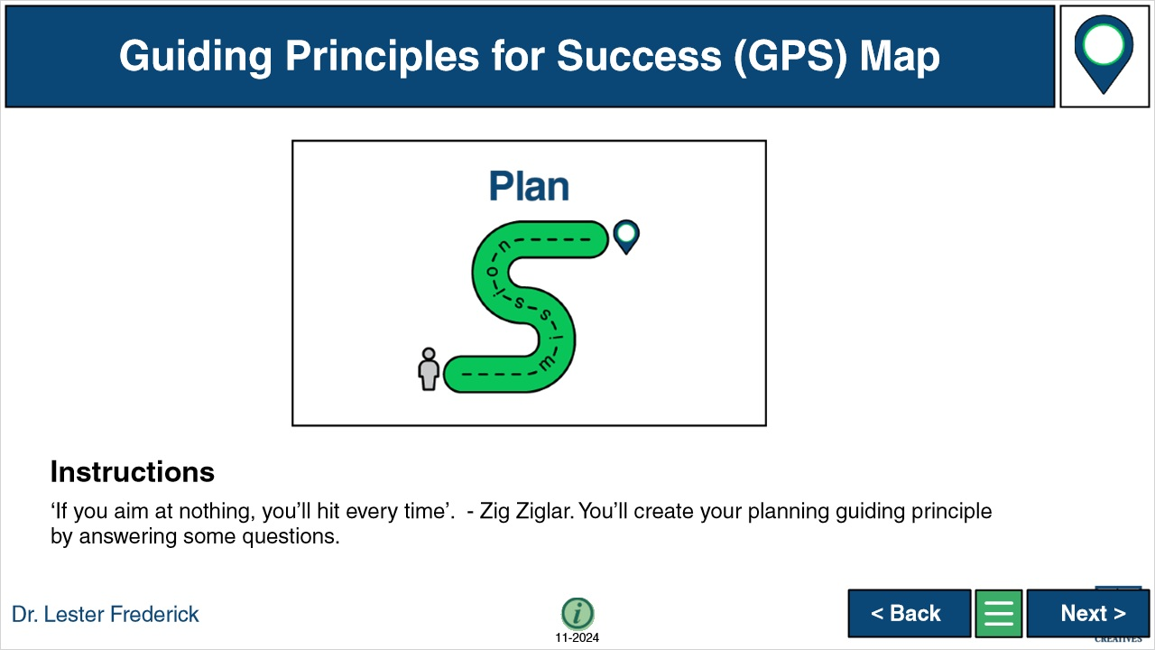

**Notes:**

### Untitled Layer 1 (Slide Layer)

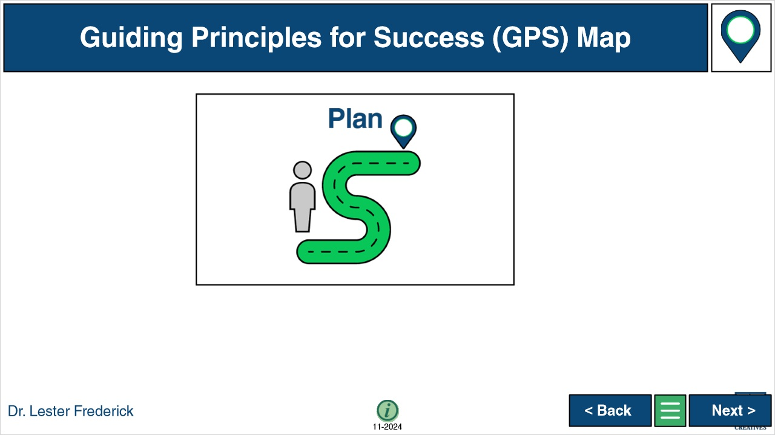

## 1.34 Q Slide 5 - Example - Start



**Notes:**

### Untitled Layer 1 (Slide Layer)

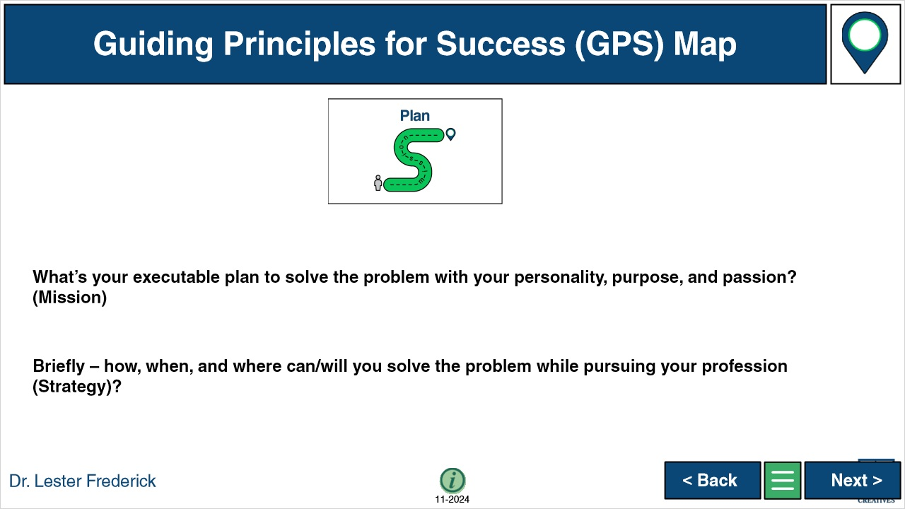

## 1.35 Q Slide 5 - Answer - Start

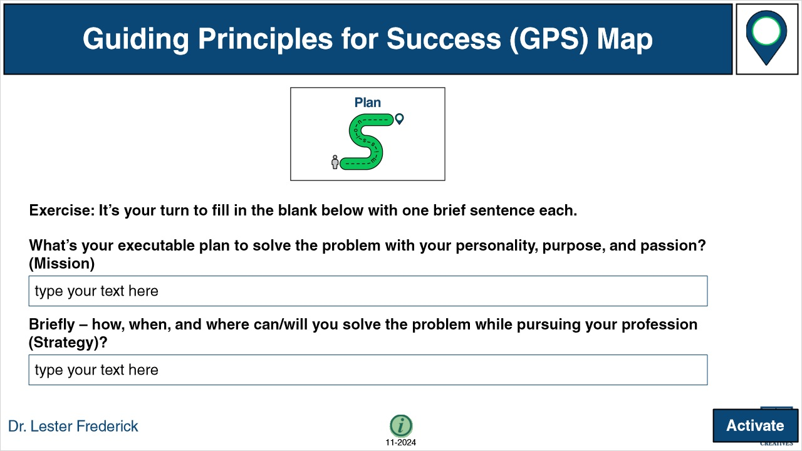

**Notes:**

### Untitled Layer 1 (Slide Layer)



## 1.36 Q Slide 5 - Optional Reflection Notes



**Notes:**

### Untitled Layer 1 (Slide Layer)



## 1.37 Q Slide 6 - Explanation - Start



**Notes:**

### Untitled Layer 1 (Slide Layer)



## 1.38 Q Slide 6 - Instructions - Start

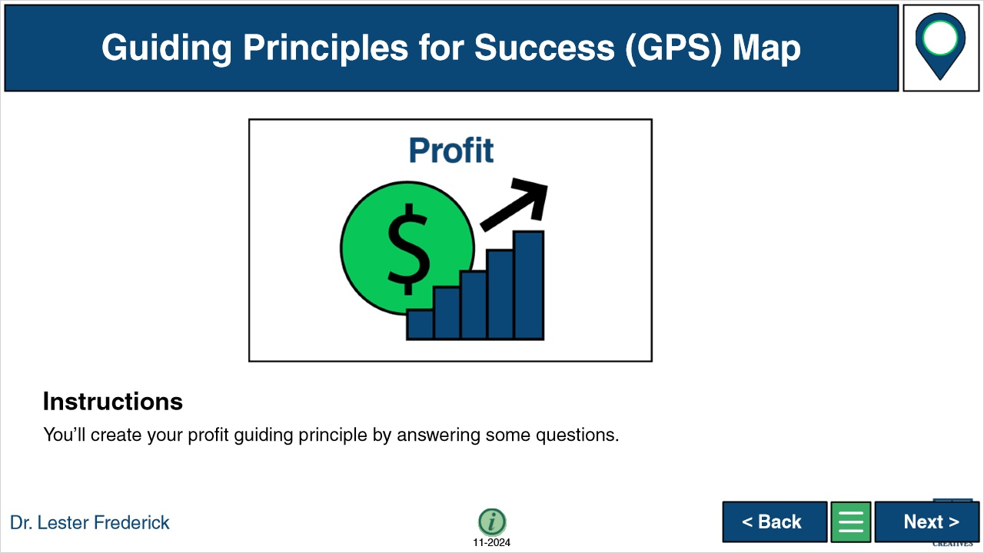

**Notes:**

### Untitled Layer 1 (Slide Layer)

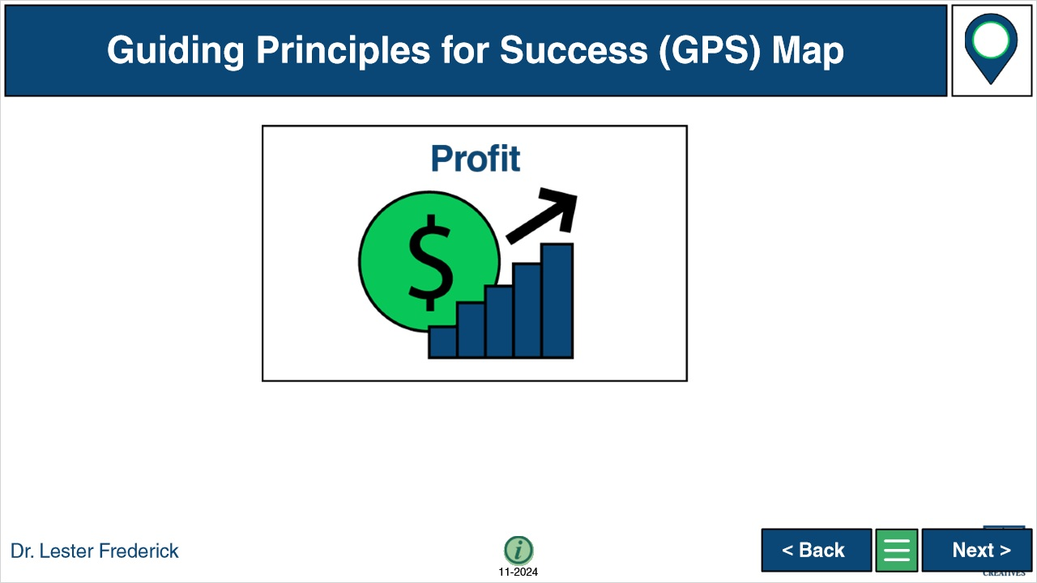

## 1.39 Q Slide 6 - Example - Start



**Notes:**

### Untitled Layer 1 (Slide Layer)

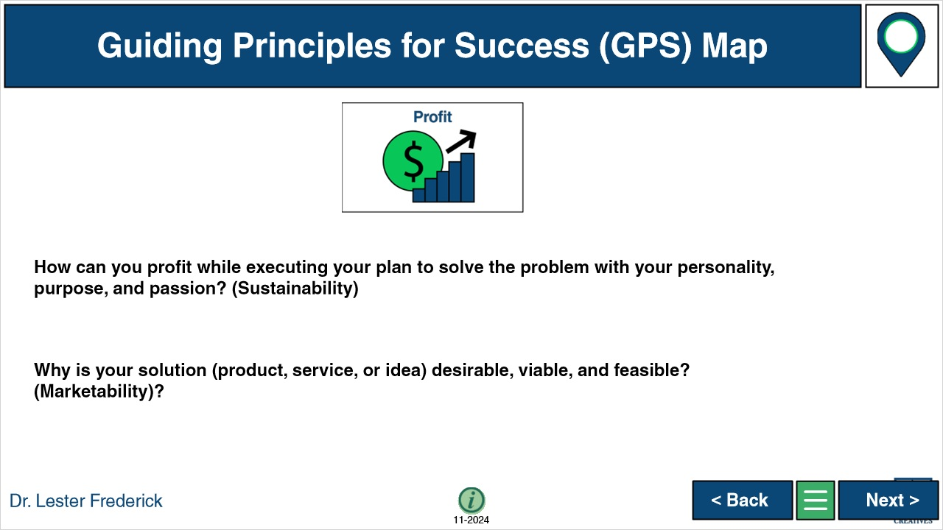

## 1.40 Q Slide 6 - Answer - Start

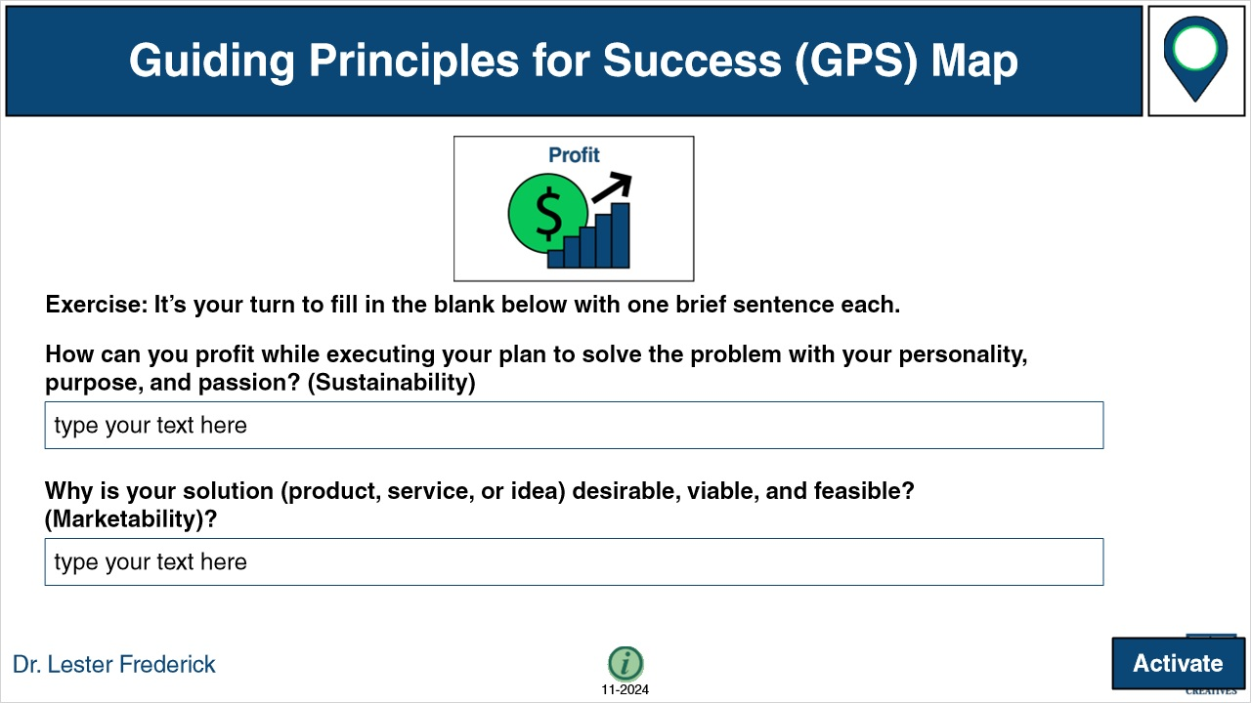

**Notes:**

### Untitled Layer 1 (Slide Layer)



## 1.41 Q Slide 6 - Optional Reflection Notes



**Notes:**

### Untitled Layer 1 (Slide Layer)



## 1.42 6 Answers

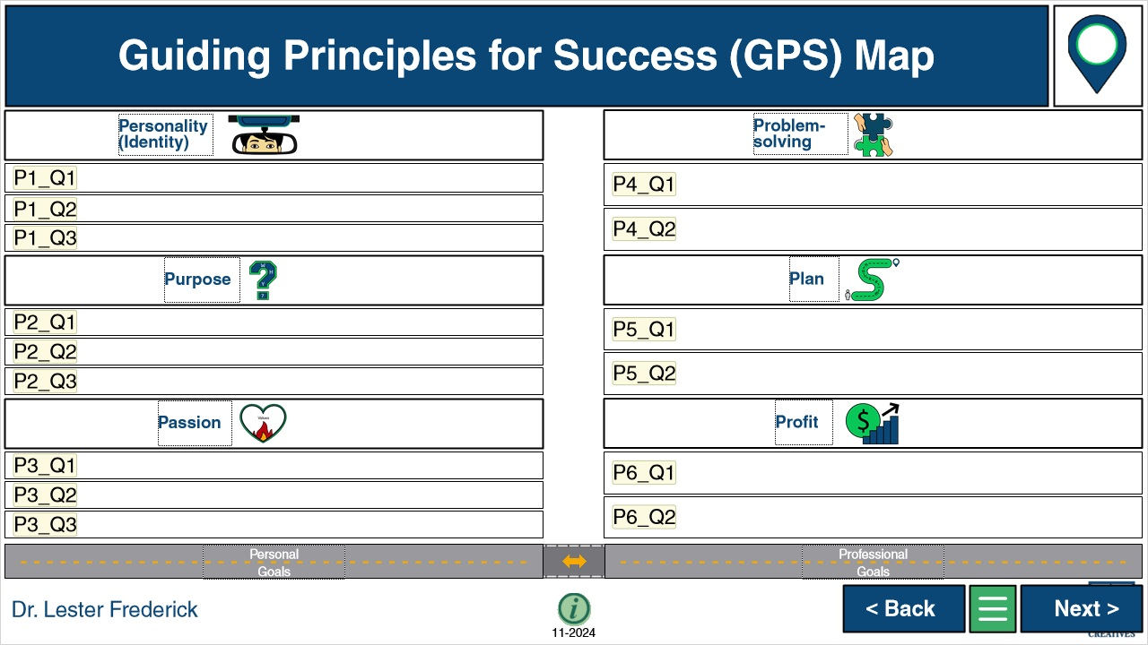

**Notes:**

### Untitled Layer 1 (Slide Layer)



## 1.43 Slide 7 - Optional Reflection Notes



**Notes:**

### Untitled Layer 1 (Slide Layer)



## 1.44 Drag and Drop

*(Drag and Drop, 0 points, 1 attempt permitted)*

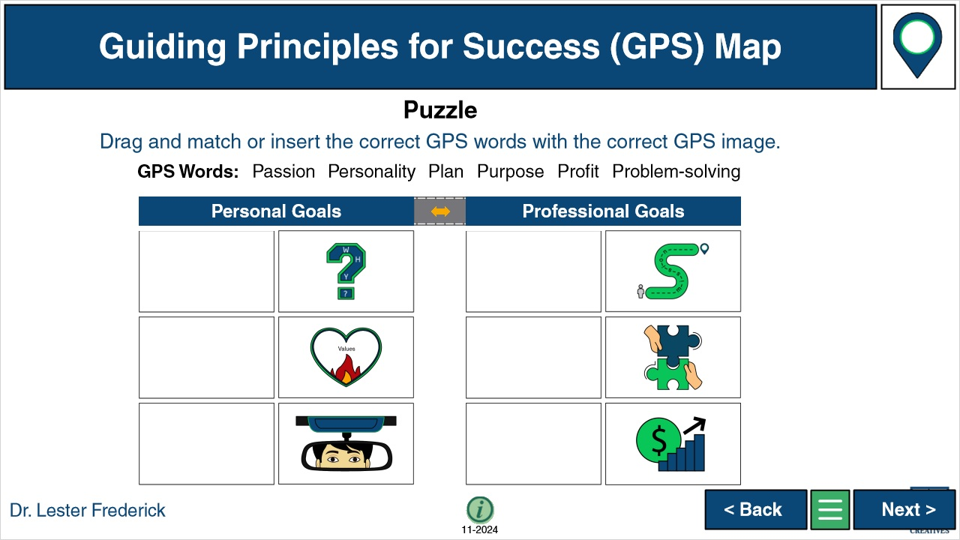

| Drag Item | Drop Target |
| --- | --- |
| Purpose | Drop1 |
| Passion | Drop2 |
| Personality | Drop3 |
| Plan | Drop4 |
| Problem-solving | Drop5 |
| Profit | Drop6 |

| Drag and drop properties |
| --- |
| Return item to start point if dropped outside any drop target |
| Snap dropped items to drop target (Stack random) |
| Allow only one item in each drop target |
| Delay item drop states until interaction is submitted |

**Notes:**

### play (Slide Layer)



### Incomplete (Slide Layer)

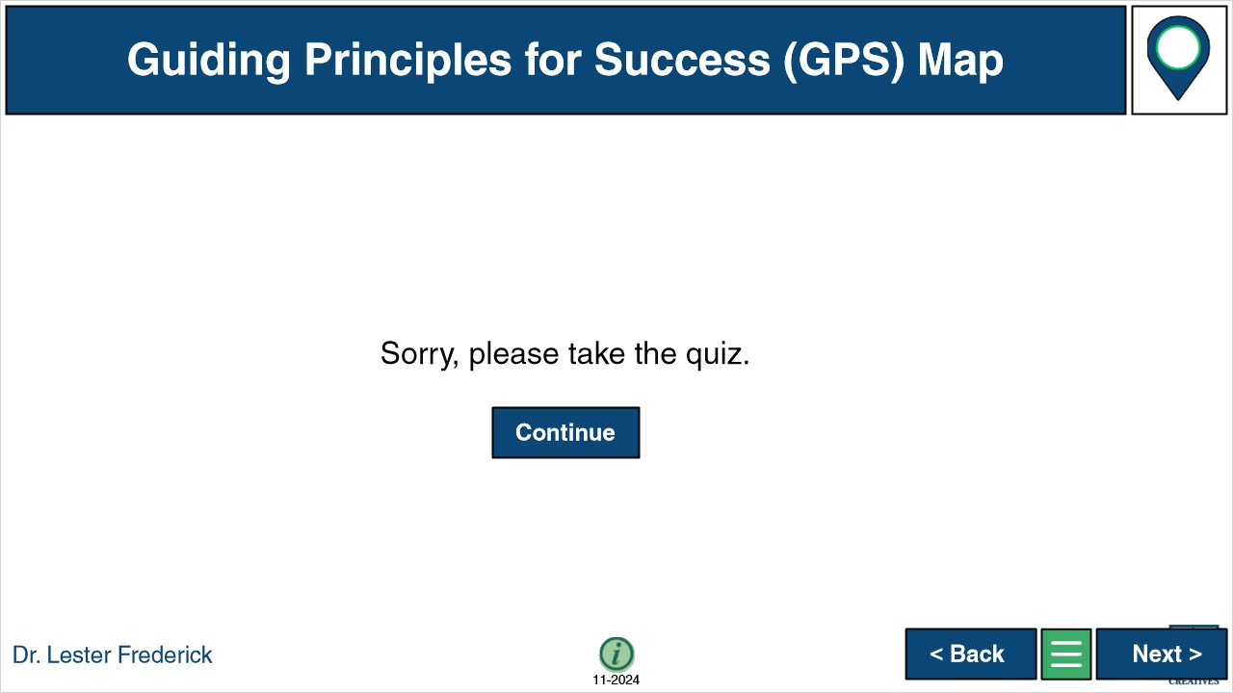

### Untitled Layer 1 (Slide Layer)



## 1.45 Slide 7 - Optional Reflection Notes

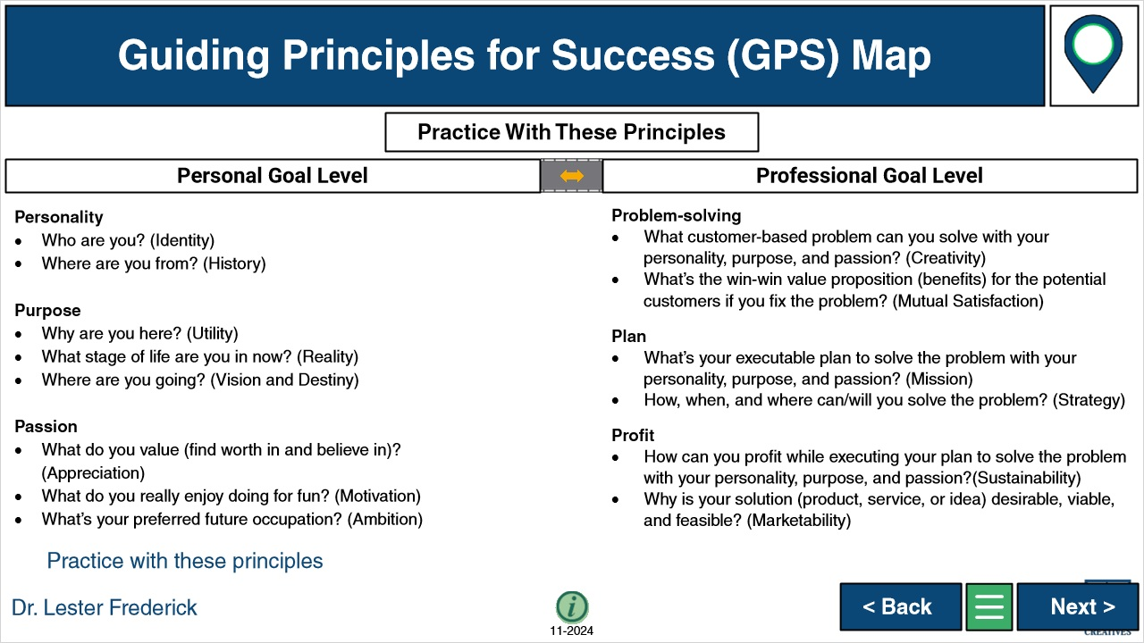

**Notes:**

### Untitled Layer 1 (Slide Layer)



## 1.46 Conclusion

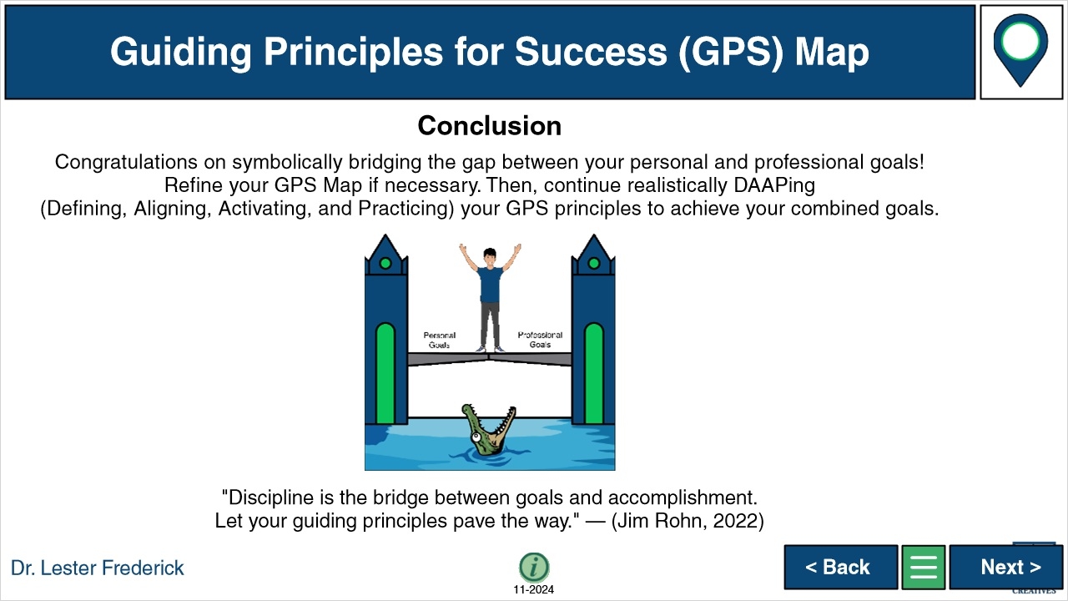

**Notes:**

### Untitled Layer 1 (Slide Layer)



## 1.47 6 Answers Repeat

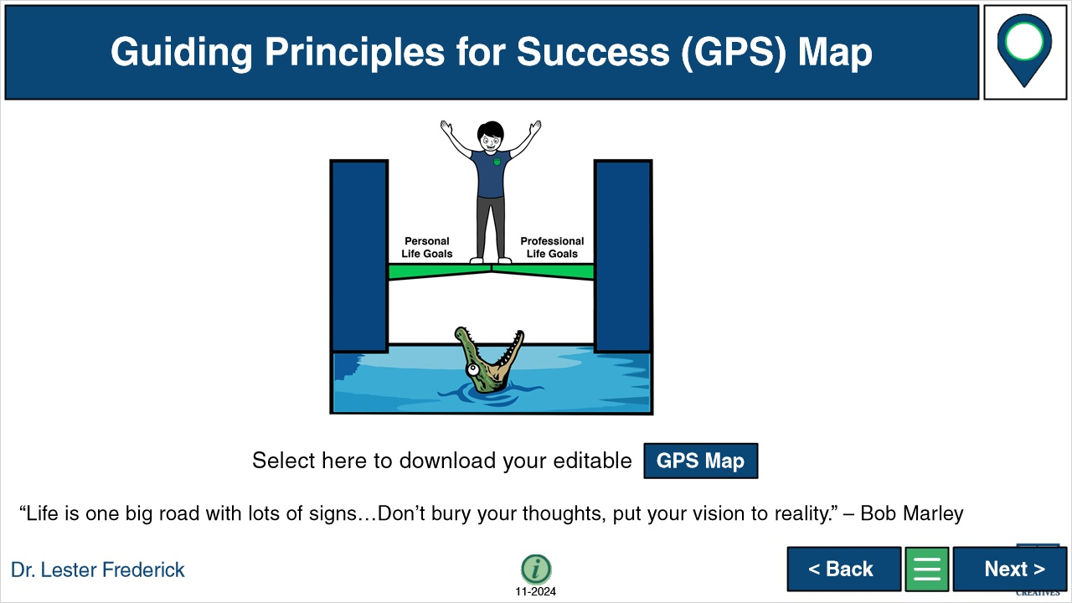

**Notes:**

### Untitled Layer 1 (Slide Layer)



## 1.48 Slide 8 - Optional Reflection Notes



**Notes:**

### Untitled Layer 1 (Slide Layer)



## 1.49 References

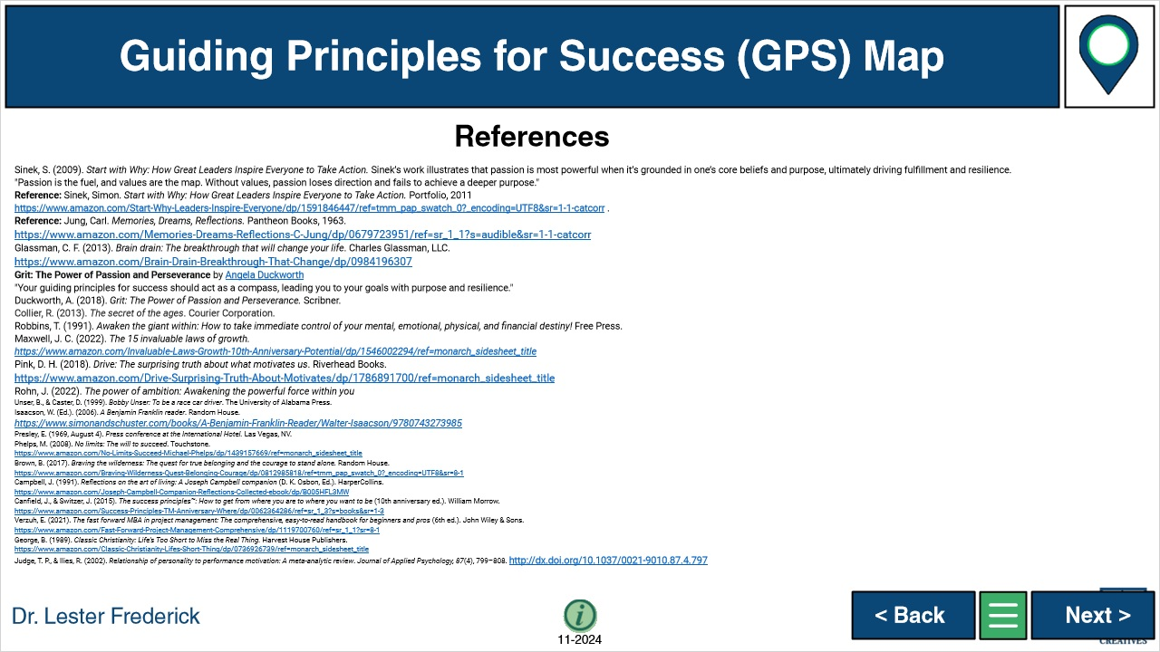

**Notes:**

### Untitled Layer 1 (Slide Layer)



## 1.50 Appendix

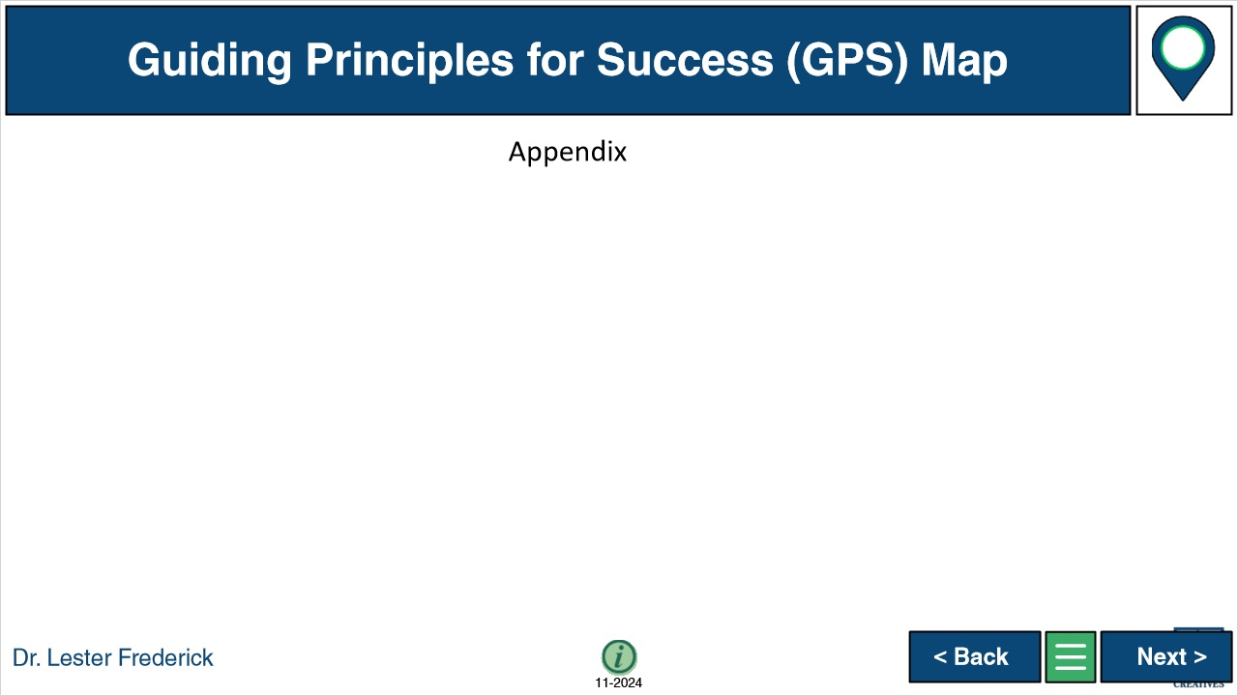

**Notes:**

### Untitled Layer 1 (Slide Layer)



## 1.51 Personality Final Slide 1

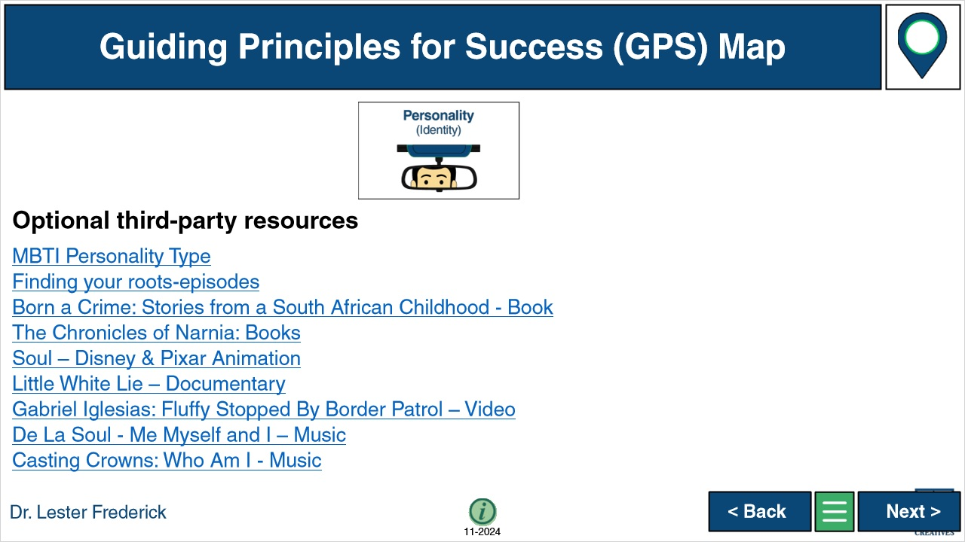

**Notes:**

### Untitled Layer 1 (Slide Layer)



## 1.52 Purpose Final Slide 1

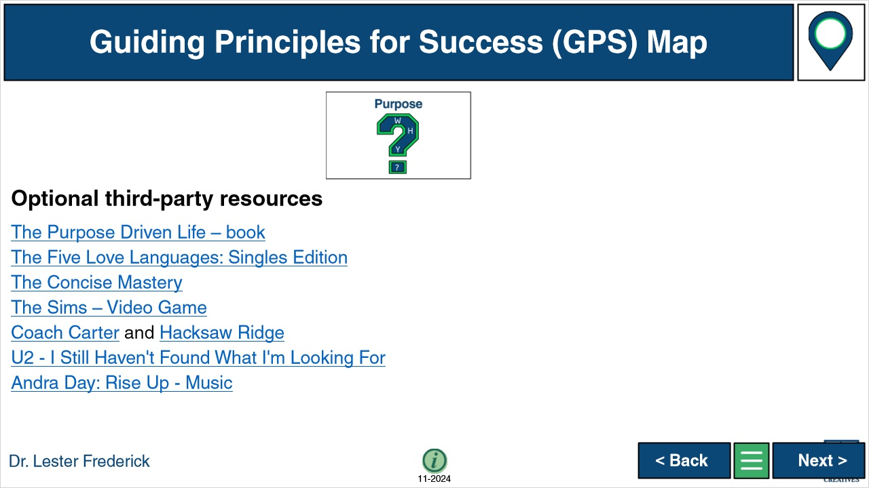

**Notes:**

### Untitled Layer 1 (Slide Layer)



## 1.53 Passion Final Slide 1



**Notes:**

### Untitled Layer 1 (Slide Layer)



## 1.54 Problem-Solving Final Slide 1

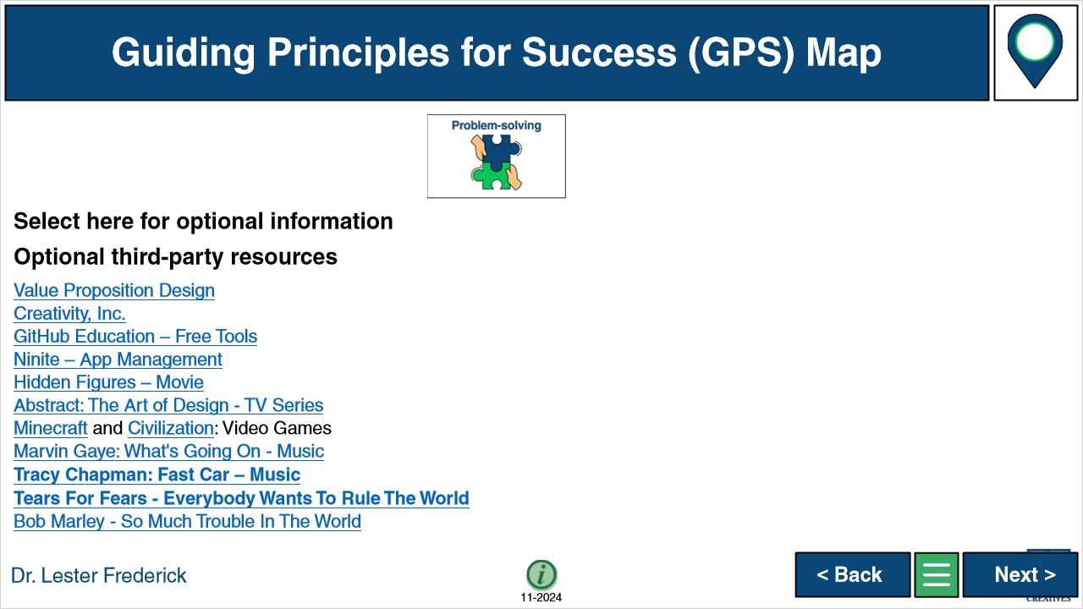

**Notes:**

### Untitled Layer 1 (Slide Layer)



## 1.55 Plan Final Slide 1



**Notes:**

### Untitled Layer 1 (Slide Layer)



## 1.56 Profit Final Slide 1

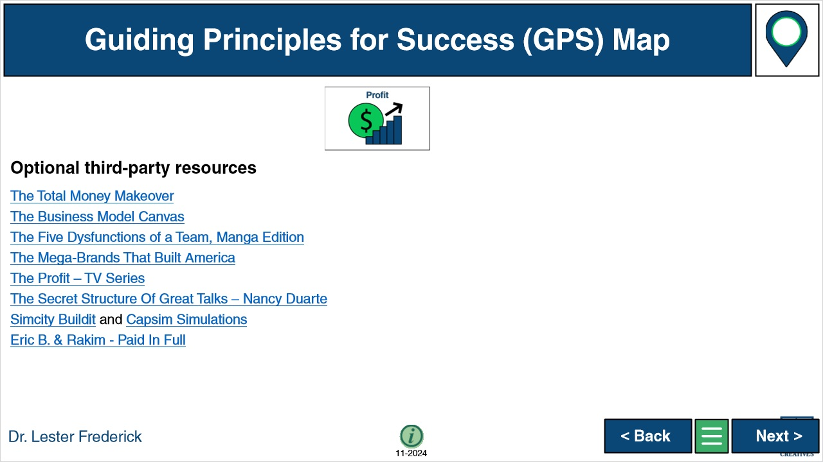

**Notes:**

### Untitled Layer 1 (Slide Layer)

